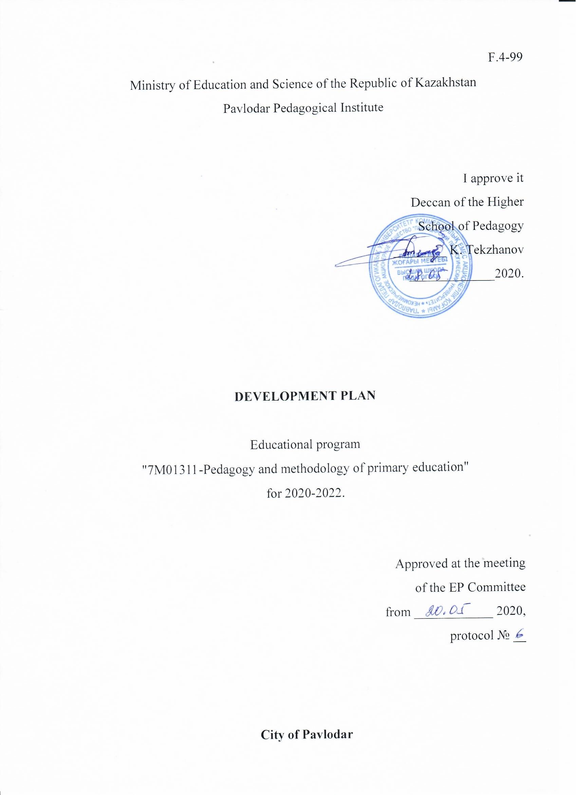

F. 4-100

**1 Analysis of the implementation of the ЕP**

1.1 Information about the educational program (ЕР).

The educational program "7M01311-Pedagogy and Methodology of primary education" is based on the modular principle, contains competencies and learning outcomes based on the Dublin descriptors, taking into account ECTS and the EHEA qualification framework. The university has fully implemented and operates a credit system of training. The ECTS credit system is used in the development of programs. The program, completed in full, gives 120 credits, which corresponds to the ECTS system and the Bologna Process.

The content of the MOS includes two cycles of disciplines: basic (DB) and profile (PD). Each cycle consists of disciplines of the university component and disciplines of the students ' choice.

The purpose of studying the disciplines of the university component is to provide fundamental training for students in the specialty, to create opportunities for" education through life", which ensures the social security of graduates in the event of changes in the labor market.

The elective component ensures the choice of disciplines, which determines the possibility of individual training of the student, taking into account the specifics of socio-economic development and the needs of the region, the established scientific school and the individual interests of the student.

The purpose of DB training is to create conditions for the development of creative potential, initiative and innovation, to provide in-depth knowledge, psychological and pedagogical character as the foundation of professional education in the field of primary education.

The purpose of PD training is to provide deep theoretical knowledge and practical experience in the field of primary education, to form the competitiveness of undergraduates in the labor market, to provide opportunities for the fastest possible employment in the specialty.

To meet the needs of students in the educational program in obtaining postgraduate education, the preparation of masters is carried out in the state and Russian languages

The main place in the formation of educational programs is allocated to a group of employers and all interested parties: students, partners, etc. The role of employers in the formation of educational programs is invaluable, thanks to them, the university understands what a graduate should be, what skills and abilities he should possess, that is, thus, the graduate model is developed and adjusted.

Students of Pavlodar Pedagogical University are the main consumers of educational programs, so their interests are primarily taken into account in ensuring the quality of the educational process.

For the implementation of the ЕP, the university develops QED, which describes all the disciplines of the component of choice, indicating the purpose of the study, a brief content (main sections), pre and post-requirements. The QED is available for students on paper and electronic media (at the AIS "PLATON", at the departments).

Meetings of students with advisors are organized for the presentation and selection of disciplines and the formation of their individual trajectory. When choosing a master's degree, the student is guided by the standard curriculum, the catalog of elective disciplines, and the recommendations of the adviser.

Educational programs are designed in such a way that students acquire competencies that will bring them professional success. In order to meet the needs of different groups of students, the ЕP includes elective disciplines necessary in the course of future work.

The ЕP provides components for preparing students for future professional activities and forming general cultural, general professional and special competencies, intellectual and academic skills.

An important factor in assessing the quality of ЕР development is the existence of cooperation agreements with foreign partner universities. The university management creates favorable conditions for the functioning of joint work with foreign universities. Over the past 3 years, the university has signed more than ten agreements, agreements with foreign universities on cooperation, on internships of students, on scientific exchange.

The purpose of the educational program "7M01311-Pedagogy and methods of primary education" is to train competitive highly qualified personnel with high spiritual and moral qualities, capable of independent thinking and ensuring the progressive scientific, technical, socio-economic and cultural development of society.

The basis for determining the purpose of the educational program is the social expectations of society for the intellectual, personal and behavioral qualities and skills of the graduate for independent life, productive professional activity in modern society.

The development strategy provides for the annual updating of the goal of the educational program "7M01311-Pedagogy and methods of primary education" at the meeting of the OP Committee, a discussion on compliance with the mission, goals and objectives of the Pavlodar Pedagogical University. The mission of the PPU is to become a regional scientific and pedagogical center that implements the state policy in the field of pedagogical education and science, ensuring the competitiveness and sustainable development of the education system of the Pavlodar region. The strategic goal of the PPU is to train highly qualified teachers who are competitive and in demand in the labor market. In addition, the goals, objectives and content of the educational program are discussed with employers, who make their suggestions and recommendations for changing or improving them.

This approach (subordination and interdependence of the mission and strategic goal of the university and the mission and the purpose of the educational program; involvement of employers in the examination of the educational program) ensures the consistency and complexity of the activities of the structural divisions of the university involved in the implementation of the educational program "7M01311 – Pedagogy and methods of primary education".

Students participate in the development of the OP through proposals of disciplines in the QED in accordance with their educational needs; a questionnaire for satisfaction with the educational program.

In order to form professional competencies in all disciplines of the educational program, both in the profile, and in the scientific and pedagogical profile, a greater number of classroom hours are allocated for practical classes.

Undergraduates, as well as other Internet users, have access to all educational documents, including catalogs of elective disciplines (QED) of the educational program, from their electronic page.

The QED is a systematized annotated list of all the disciplines of the component of choice.

The structure of the QED includes: volume (number of credits); pre-and post-requirements, study goals; summary of the discipline (main sections); expected results (knowledge, skills, and competencies acquired by students).

For each discipline, undergraduates can choose at least 1 elective discipline from 2 offered ones (in the departments and library of the university).

1.2 Information about students

A characteristic feature of modern Russian education is the appeal to the student: a qualitative transformation in the learning environment, aimed at increasing the independence of students and their ability to think critically through a result-oriented approach. This approach to the main outcome of the educational process creates the correct teaching in terms of knowledge, understanding and capabilities, and not the means and methods of teaching that teachers use to achieve these results.

All conditions are created for students at the university. The implementation of the principle of student-centered learning is carried out through the design and organization of the educational process, in which:

- curricula are created in accordance with international standards;

- students act as full members of the subject-subject relationship, in which they take a share of the convenience for learning, discuss and complement each other and with the teacher in choosing goals and ways to achieve them, following at this time only the best ways to use and improve existing skills and knowledge;

- an individual trajectory is built-such an organization of the educational process, in which an individual approach and an individual form of training are priority, while the student rules the free choice of disciplines and only he is responsible for himself and for his trajectory of performance;

- the score accurately reflects the achievement of the master's student;

- the teacher acts as a teacher-manager, not a translator of educational information;

- information is used as a means of organizing activities, not the purpose of training;

- training programs and technologies are formed based on the requirements of the future profession and the capabilities of the master's student;

- download the achievements of undergraduates and their reviews when evaluating the work of the teaching staff;

- professional growth of teaching staff focuses on the needs of undergraduates and improving the quality of their achievements;

- employees and undergraduates are required to participate in the development of educational programs and quality assurance measures;

- the main focus is on the organization of various activities of undergraduates.

Expected expectations for undergraduates:

- development of opportunities for self-control, self-learning;

- reminders of clear learning goals, developing a learning strategy that includes classroom and extracurricular activities, and monitoring the achievement of learning goals.

For faculty members:

- joint responsibility for the implementation of internal quality assurance;

- working in partnership with magistrates, strengthening the mutual respect of the teacher and the student;

- improvement of the form and pedagogical methods of teaching;

- regulated feedback on the techniques and methods used to evaluate and adjust pedagogical methods;

- professional and personal growth.

The university has an open dialogue, feedback between magistrates, teaching staff and co-managing administrators, expressing the needs and aspirations of undergraduates. All stakeholders are involved in a constructive discussion of the development and implementation of the program. Undergraduates are provided with a choice and satisfaction of various needs.

The academic load of the master's student is made up with the training of his individual abilities and capabilities and is determined by the duration of the academic lesson and the volume of academic hours, accompanying academic hours, for various types of academic work, consists of auditory hours, independent work under the guidance of a teacher, independent work, participation in controlled measurements.

The academic period is a semester of 15 weeks.

Thus, the university has developed and implemented a systematic competent approach to training specialists in various fields within the framework of the specialty training program in accordance with the SES of the Republic of Kazakhstan with the training of the university specification.

With the help of which the individual trajectory of the master's student is realized. A curriculum is developed for each elective discipline. In compatibility with the curriculum, other components of the educational and methodological complex of the discipline are developed.

The educational program shows that the chosen content, forms and methods of teaching the proposed course contribute to the successful formation of competencies necessary for the further professional activities of graduates.

1.3 Internal conditions for the development of the ЕP

Classrooms equipped with modern computers and classrooms with an interactive whiteboard are used to ensure the high quality of the classes. All disciplines are provided with methodological guidelines for independent implementation of practical work, lecture notes to increase the availability of educational material of disciplines in the state and Russian languages.

To improve the quality of training in the ЕP, teachers widely use innovative teaching methods: practical work in most disciplines is carried out using computer technology and specialized software. There are specialized offices and laboratories

For the implementation of the ЕP "7M01311 – Pedagogy and methods of primary education", the UMCS has been compiled, which includes the following structural elements: SES; RUP; map of educational and methodological security; guidelines for passing professional practices; guidelines for the implementation of DR; guidelines for the final State certification. The content of the disciplines is described in more detail in the ЕMСD and the syllabus of the disciplines. The security of the OP UMKD is 100%.

The effectiveness of the implementation of educational and professional programs is provided by the ЕMСD, which includes a standard curriculum, syllabuses, a map of the educational and methodological security of the discipline, a lecture complex, methodological guidelines for practical classes, materials of the SRO and SROP, test tasks for the boundary and final control.

In the development of teaching and didactic materials of teaching staff, modern scientific research in the field of pedagogy and psychology is used, which corresponds to the goals of training. In the ЕMСD, in the section "Map of educational and methodological security of the discipline", the literature is presented, which reflects the achievements of science over the past 3-5 years (the map is systematically updated).

In order to effectively implement the educational program, work is constantly being carried out on the introduction of active and innovative teaching methods, which helps students learn active ways to acquire new knowledge, allows them to master a higher level of social activity, also stimulates the creative abilities of students and helps to form functional literacy.

Modernization of the process of teaching disciplines is due to modern educational technologies, comprehensive methodological support for all its components. The educational process of the specialties is fully provided with all the necessary information sources: textbooks, teaching aids, methodological manuals and developments in academic disciplines, active handouts and instructions for independent work, access to online educational resources. There are electronic textbooks, video lectures, lectures-presentations, etc. There are interactive whiteboards, multimedia projectors, computer classes connected to the local Internet network and Wi-Fi, there are multipliers and copiers. The educational process is constantly equipped with multimedia classrooms and specialized laboratories in accordance with the requirements of the standards.

One of the directions in the work of the department is the introduction of information and communication technologies( ICT), which act as a means of interactive learning. ICTs include a wide range of digital technologies used for the creation, transmission and dissemination of information and the provision of services: computer equipment, software, cellular communications, e-mail, wireless and cable networks, multimedia, and the Internet.

Special attention is also paid to creative learning technology. Creative technology of education, which aims to develop a person's creative potential, foster courage of thought, confidence in their creative abilities, and the ability to generate new non-standard ideas.

1.5 Information about the PPP implementing the ЕP

The activity of the teaching staff of the OP "7M01311-Pedagogy and methods of primary education" is based on the current trends of the world educational space, focusing on the training of competitive specialists with professional knowledge, skills, skills, key competencies formed in accordance with the state mandatory standards of higher professional education.

The personnel policy of the university corresponds to the mission and strategy of the university development and is aimed at preserving and developing the professional potential of the teaching staff, creating conditions for improving the scientific and pedagogical, qualification and career growth of teachers and employees, creating mechanisms to ensure differentiated remuneration, creating a favorable moral and psychological climate in the university staff.

The HR policy is focused on the formation of a unified, cohesive team of highly qualified professionals.

In connection with the transition to student-centered learning, the management of the educational program supports the change in the role of the teacher: the specific features of the change in the role of the teacher are that the university provides the development of such educational programs that motivate students to play an active role in the joint creation of the learning process, and the assessment of student performance should reflect this approach. The task of the teacher is to provide conditions and promote learning, in the conditions of mass higher education and a more diversified student body, STS will be used more widely due to the increasing requirements of students for quality. The student-centered approach allows you to organize training in different ways, so the teacher's work becomes more interesting, he becomes a facilitator. SSO forces teachers to review and improve their courses and teaching methods, as they receive adequate and constructive feedback from the students involved. Increased student engagement and a higher level of participation makes teaching more interesting. SSO can offer a much higher level of professional development in terms of building the knowledge, skills and competencies needed for both personal improvement and career growth. The student-centered approach provides teachers with greater freedom in choosing teaching paths. The teacher becomes an assistant facilitator, where the responsibility for learning is shared, and the learning process is discussed; students are considered as individuals-their experience, characteristics, perceptual abilities, interests and needs are taken into account; students "construct" their own content through active learning, reflection, as well as through research and discovery.

The key indicators used at Pavlodar Pedagogical University are of great importance for the work and are relatively measurable. At the university, there are both educational and methodological indicators, and research indicators:

1. Pedagogical effectiveness – classroom and individual classes, consultations, etc.

2. Scientific work – monographs, textbooks, teaching aids, publication in journals with an impact factor of the Webofscince (ThomsonReuters), Elsevier (SCOPUS) databases, publications in journals of the KKSON MES RK, publications in journals recommended by the Higher Attestation Commission of the CIS countries (journals of the Higher Attestation Commission, RSCI) and foreign journals,

3. Indicators of educational and methodological work include work on the creation of an electronic textbook, the publication of a textbook, the conduct of open classes, the publication of methodological guidelines for disciplines.

1.6 Characteristics of ЕP achievements:

- plans for the development of the educational program there is a public discussion at the Educational and Methodological Council of the Higher School of Pedagogy with representatives of all interested parties;

- ensure the uniqueness and individuality of the program development, its consistency with national and regional priorities and the development strategy of the educational organization;

- annual updating of educational programs taking into account the interests of employers and the needs of students;

- organization of a stable system of professional development and professional level of teaching staff;

- the adequacy of individual planning of the work of the teaching staff in all types of activities (educational, methodological, scientific, educational, etc.), monitoring the effectiveness and effectiveness of individual plans;

- providing monitoring of PPP satisfaction;

- cooperation with employers during the educational process (management and review of scientific papers, etc.), interviewing employers to identify their opinions on the quality of educational services;

- availability of free Wi-Fi;

- availability of electronic educational resources;

- availability and staffing of the ЕMСD in all disciplines of the educational program.

**2 Educational program development plan:**

|  |  |  |  |  |
| --- | --- | --- | --- | --- |
| **№**  **п/п** | **Activities** | **Deadline Responsible** | **Persons** | **Implementation mechanism** |
| 1 | External Evaluationquality of Activitiesuse and satisfaction of Consumerseducational Services | May 2021 | Zhaparova B. M., Botalova O. B. | Preparation for accreditation monitoring of the results of the educational program implementation |
| November 2020,  December 2021 | Zhaparova B. M., Botalova O. B. | Prizes in the national ranking |
| 2 | Professional orientation agitation early profiling of students of schools lyceums colleges for the profession of teacher | Annually | teaching staff | The share of coverage of educational institutions with career guidance activities is up to 100% |
| Annual formation of the base of graduates-bachelors of pedagogical sciences, entering the master's program |
| Conducting career guidance work in social networks Instagram, vk.com |
|  | Providing the labor market with competitive specialists | Annually | teaching staff | The share of undergraduates who studied under the state educational order, employed in the first year after graduation in the specialty is up to 90% |
| Annually | teaching staff | Student performance up to 97% |
|  | Modernization of the content of higher education in the context of global trends | June 2020 | Zhaparova B. M., Botalova O. B., Akhmuldinova A. N. | Educational program developed on the basis of professional standards |
| June 2020 | Zhaparova B. M.. Kenenbayeva M.A.,  Osipova S. V. Zhumasheva A. Sh. Asenova.S. Botalova O. B. | 3 updated elective subjects introduced in educational programs, taking into account the recommendations of employers |
| January 2020  May 2020 | Botalova O. B., Aspanova G. R.  Botalova O. B., Aspanova G. R. | 1. Textbook for undergraduates "Methodology and methodology of pedagogical research»;  2. Primary education abroad» |
| Annually |  | Adjusting the content of educational programs, taking into account the transition to the updated content of education |
| 6 | Information and library resources | December 2021 | Asenova N. S. | Number of digital educational resources developed:  - electronic educational publication |
| 7 | Development of academic mobility of teaching staff students | Annually | Zhaparova B. M. | Internal academic mobility in reading an elective course for EAGI students (Astana). |
| 8 | Ensuring the contribution of science to the accelerated diversification of the economy and sustainable development of the country | December 2020 - December 2021 | teaching staff | Participation in the work of the scientific Center for pedagogical research of PPU teaching staff, serving the ЕP. |
| 9 | Ensuring the contribution of science to the accelerated diversification of the economy and sustainable development of the country | Annually | teaching staff | Participation in competitive events held at the university and stimulating the research activities of undergraduates and young scientists |
| Conducting joint research with universities and research centers in Kazakhstan and abroad. |
| Percentage of teaching staff involved in the implementation of fundamental and applied programs |
| The share of publications in scientific journals with a non-zero impact factor |
| Annually | Асенова Н.С., Жумашева А.Ш, Боталова О.Б., Кененбаева М.А., Ахмульдинова А.Н., Осипова С.В. | The number of prize-winning students (awarded the first, second and third degrees) of national and international scientific conferences, Olympiads, competitions |
| teaching staff EP | Percentage of full-time students involved in the scientific activities of the university 45% |
| 10 | Increasing and strengthening the international prestige of the PPU, establishing and developing cooperation with foreign partners | 2021 | Botalova O. B., Kenenbayeva M. A. | Number of students who went abroad (international programs, conferences, internships) |
|  | 2022 | Osipova S.V., Aspanova G. R., | Number of teaching staff and employees who have traveled abroad (international programs, conferences, internships) |
| 11 | Increasing the civic activity of young people and fostering a new Kazakh patriotism in the context of the national idea of Mangilik el | Constantly | Aspanova G. R., Sergazina Zh. Zh. | Holding events aimed at promoting the idea of "Mangilik el" and fulfilling the tasks of the Messages of the President of the Republic of Kazakhstan N. A. Nazarbayev (training seminars, round tables, actions,meetings, etc.) |
| Aspanova G. R., Sergazina Zh. Zh. | Percentage of undergraduates involved in socially useful activities 45% |
| Aspanova G. R., Sergazina Zh. Zh. | The share of undergraduates (19%) participating in the implementation of socially significant projects in the region and the republic, within the framework of the state social order (the "Zhasyl El" program, the KVN league, the debate movement, youth forums, youth leadership schools, etc.) |
| The share of undergraduates (34%) participating in the activities of youth organizations ("Zhas Otan", the Alliance of Students of Kazakhstan, the Student Government, etc.) |
| Conducting explanatory work on the issue of combating corruption in the university with the involvement of authorized state bodies and youth organizations of the university |
| Conducting a set of awareness-raising activities to prevent offenses and spread the ideas of destructive religious sects among young people with the involvement of law enforcement agencies and clergy (training seminars, round tables, actions, meetings, etc.) |
| 12 | Coverage of young people with cultural and recreational and preventive measures to reduce social risks | Constantly | Sakenov D. Zh., Botalova O. B., | The share of undergraduates covered by the work of the circles - 45% |
| teaching staff | The share of students covered by the work of sports sections – 30% |
| Curators | The share of students participating in regional, national and international creative competitions, shows, intellectual games, sports competitions and tournaments -18% |
| 13 | Strengthening human resources and improving labor efficiency | Constantly | Zhaparova B. M. | Staffing of the teaching staff according to the staffing table 100% |
| Staffing of the full-time staff of the ЕP from the total number of employees, including in each field of training 100% |
| 90% staffing of primary school teaching staff with basic education |
| Staffing of the teaching staff of the ЕP with academic degrees and titles from the full-time teaching staff 70% |
| The non-negligible percentage of the PPS settling down is 70 % |
| 14 | Improving the scientific potential and the level of methodological and fundamental training of the university's teaching staff on the basis of advanced training, internships in scientific centers of the republic and abroad | Constantly | Asenova N. S., Zhaparova B. M., Kenenbayeva M. A. | The number of teaching staff who have completed advanced training in the country at the expense of the state budget (at least 2 teaching staff annually) |